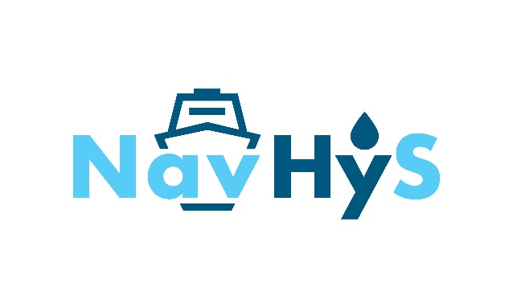
PRESS RELEASE

NavHyS Project launches to advance liquid hydrogen innovation in shipping

Bremen, January 21-22, 2025 – 14 leading companies from across Europe have gathered at the ECOMAT Center in Bremen, Germany, for the official launch of NavHyS, a European project dedicated to the deployment of liquid hydrogen in maritime applications. By bringing together expertise from the space industry, shipbuilding, transportation, and energy and safety, NavHyS aims to advance sustainable shipping technologies and support the decarbonisation targets of the EU Green Deal in this sector.
Marie-Sophie Nizou, Program Manager at ArianeGroup and coordinator of NavHyS, highlights the potential of liquid hydrogen as a promising energy carrier for shipping, particularly for the use in Service Operation Vessels providing maintenance for offshore wind farms:
“Currently, near-coast projects rely on gaseous hydrogen. For long-distance shipping, liquid hydrogen offers more advantages because of its high energy density. However, storing this fuel requires tanks capable of maintaining extremely low temperatures (-253°C). The severe constraints linked to cooling and insulating tanks on board ships are a technological challenge here.”
To address this, the NavHyS project is developing an innovative below-deck liquid hydrogen storage and fuel system, to be integrated in Service Operation Vessels. This system will be compatible with any propulsion system, supplying gaseous hydrogen at 5 bar and ambient temperature to produce from 500kW to 2MW.
Nicolas Hardouin, Program Manager at ArianeGroup and NavHyS Work Package Leader, underscores the transformative impact of this technology:
“The design of the liquid hydrogen fuel system, drawing on our experience of space system architectures and technologies and below-deck integration in the ship, represents a disruptive innovation in comparison with previous maritime projects and design guidelines.”
Over the next 36 months, the consortium will work toward key milestones to successfully develop and test the system. By the end of the project in 2027, NavHyS will deliver the approved design of a vessel equipped with a 200-300 m³ tank below-deck, carrying 12t to 18t of liquid hydrogen bunkered in less than 2 hours. This will enable a zero-emission strategy for the construction and maintenance of offshore wind farms, where the long distances to plants necessitate an operational cycle of up to 10 days, requiring large amounts of fuel.
By 2030, the project is expected to reach TRL 7-8. By 2035-2040, the technologies developed during the project are anticipated to expand to multiple EU ports, expecting deployment of 12 stations supporting 30 ships.
NavHyS is a 3-year project funded by the European Union and supported by the Clean Hydrogen Partnership, with a funding of € 5M.
Valérie Bouillon-Delporte, Executive Director of the Clean Hydrogen Partnership, stresses the project’s importance:
“The Clean Hydrogen Partnership is proud to support this pioneering project, which explores in-hull integration of liquid hydrogen tanks for maritime applications. NavHyS is fully in line with the Clean Hydrogen Partnership’s core mission, which is to promote innovations that drive both the energy transition and the competitiveness of European companies; it will play a crucial role in accelerating the decarbonisation of the sector while ensuring that Europe remains at the forefront of clean hydrogen technology.”

List of the project partners:

ArianeGroup – Germany is an expert in the handling, management and safekeeping of liquid hydrogen. It is now proposing for maritime, aeronautics and railroad application its liquid hydrogen portfolio. ArianeGroup is the coordinator of the project and is in charge of designing the architecture and testing the liquid hydrogen fuel system. https://ariane.group/en/


North Star Shipping – United Kingdom is a shipping company that owns and operates a fleet of vessels engaged in the offshore industry, providing comprehensive operational experience. North Star has committed to decarbonisation pathway accordingto IMO regulations and to achieve net-zero emissions by 2045. It is dedicated to developing zero-emission vessels using sustainable fuels, particularly hydrogen. North Star will define the operations scenario and confirm the operability of the proposed design. https://www.northstarshipping.co.uk/

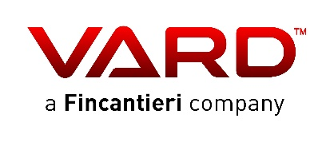
VARD Design (VARD) – Norway is the ship design and engineering arm of VARD Group, a company in the Fincantieri Group. VARD is a shipbuilder specialising in design and construction of highly advanced ships within the offshore, naval and expedition cruise segments. VARD is committed to be leading
in the green- and technology transition within maritime operations. The Group has extensive experience in dealing with various ship fuels like Liquefied Natural Gas, methanol and ammonia and has been involved in several research projects focused on energy efficiency and ship- and system design to accommodate for the use of alternative fuels in future ships. VARD will design and engineer the ship. https://www.vard.com/


ENGIE – France is a historical leader in gas marketing in France and the first operator of gas infrastructure in Europe. It is a demonstrator of green hydrogen injection into the gas distribution network in France. It has also contributed to the construction and maintenance of hydrogen stations for buses. ENGIE will design the supply chain and bunkering station.
https://www.engie.com/en

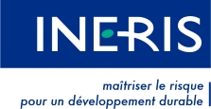
INERIS – France is dedicated to the prevention of risks posed by economic activities to the health and safety of people, property, and the environment. The Institute specialises in research and expert analysis of technological hazards, aiming to gain a better understanding of phenomena that can damage health, assets, and the environment. INERIS will contribute to hazard identification and leak frequencies evaluation. https://www.ineris.fr/en


Research Institutes of Sweden AB (RISE) – Sweden is a research institute and innovation partner. RISE has extensive experience in safety analysis, particularly in hydrogen hazards and HAZID (Hazard identification) workshops, as well as the IMO alternative design process (MSC.1-Circ.1455). RISE will bring competencies in safety analysis, hydrogen hazards assessment, and HAZID analysis. https://www.ri.se/en

Bureau Veritas Marine & Offshore (BV) – France is a classification society with considerable expertise in gas-fueled and (hybrid) battery-powered ships. It collaborates closely with industry partners to support the energy transition towards climate neutrality in the maritime industry. Bureau Veritas will provide approval in principle for the developed technologies. https://group.bureauveritas.com/


LEITAT – Spain is a technological center that focuses on developing technologies across sectors. It manages technologies that create sustainable social, environmental, economic, and industrial value. It is a key European player in performing sustainability and circularity assessments of technologies. LEITAT will be in charge of the LCA of the NavHyS solution. https://leitat.org/en/


The University of Birmingham (UoB) – United Kingdom ranks among the world’s top 100 universities for research. With a strong track record in technology and engineering -the proposed area of collaboration- the University successfully bridges the gap between industry and academia. UoB’s key role will focus on scaling up the technology, as well as on TCO, CAPEX and OPEX evaluation. https://www.birmingham.ac.uk/
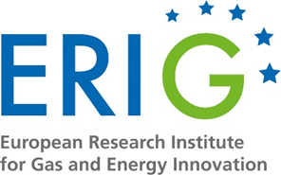
The European Research Institute for Gas and Energy Innovation (ERIG) – Belgium is a European research and development organisation with the objective to guide gas in the transition process towards a future renewable based energy system. ERIG will ensure the dissemination, communication and exploitation of the project results. https://erig.eu/

Gas and Heat (GAH) – Italy is a leader in the design, construction, supply and installation of systems and tanks for the propulsion and storage of liquefied gases for marine use as well as for land storage facilities. Over the past 1.5 years, GAH’s R&D activities focused on liquid hydrogen storage systems. GAH’s key role will be the design of the LH2 fuel tank.
https://www.gasandheat.it/en/

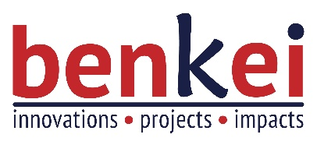
Benkei – France is a consultancy company supporting its clients in defining and implementing their innovation strategies and collaborative projects. Benkei has specialised expertise in open and collaborative innovation, as well as in setting up and managing collaborative projects. Benkei will lead and support the project coordination and management. https://www.benkei.eu/

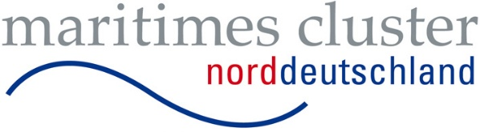
The Maritime Cluster of Northern Germany (MCN) – Germany is a maritime network founded in 2011, comprising more than 380 members from business, science, politics, and administration across the five federal states of Northern Germany- along the coastline from Poland to the Netherlands. MCN is an associated partner in the project. https://www.maritimes-cluster.de/en/

For more information, please visit www.erig.eu

Press Contact:

Katharina Römling
Project Manager
European Research Institute for Gas and Energy Innovation (ERIG)
Rue Belliard 40
1000 Bruxelles, Belgium

Tel.: +32 456 68 06 28
Mail: roemling@erig.eu

The NavHyS project aims to develop innovative solutions for the storage and use of liquid hydrogen (LH2) as a sustainable energy carrier for maritime transport. The consortium brings together 14 leading partners from 8 European countries, combining expertise from the space industry, shipbuilding, transportation, and energy and safety. Together, they are working towards the development of an innovative below-deck liquid hydrogen storage and fuel system, to be integrated in Service Operation Vessels providing maintenance for offshore wind farms. With this design, presenting a disruptive innovation compared to previous maritime projects and design guidelines, NavHyS will play a crucial role in decarbonising the shipping sector while ensuring that Europe remains at the forefront of clean hydrogen technology. Additionally, the project will benefit from synergies with the HORIZON Europe DelHyVEHR initiative, which is working to demonstrate the possibility of refuelling LH2 with a high flowrate.

